UNIT –II
SOFTWARE & NETWORKS
Computer Languages: Machine, Assembly & High Level Languages. Software: Definition Of Software-System Software-Application Software. Operating System, Functions of Operating System, Types of Operating System.
Networks: Definition- Network Types: LAN, MAN, WAN. Network Topologies: BUS, STAR, RING.MESH, Hybrid.

Software
Software refers to a collection of programs, data, and instructions that enable a computer or electronic device to perform specific tasks or functions. There are various types of software designed to cater to different needs and purposes. It is responsible for controlling, integrating, and managing the hardware components of a computer to accomplish specific task.
Software tells the computer what to do and how to do. Thus, software communicates with the hardware by organizing the control sequences, and the hardware carries out the instructions defined by software
Software is divided into two parts
- System software
- Application software
Software

System Software Application Software

USER

APPLICATION SOFWARE

SYSTEM SOFWARE

HARDWARE

System Software
- It helps in running the computer hardware and the computer system. System software is a collection of operating systems; device drivers, servers, and system utilities.
- System software is used by the computer to translate inputs from various sources into a language which a machine can understand. Basically, the OS coordinates the different hardware components of a computer i.e., System software is the communicator of user and hardware.
- System software provides the platform for users to install and run application software, and it's made up of multiple programs needed to run a computer system smoothly
Application software
- Application software consists of standalone programs that solve a specific business need.
- Any application program is dependent on a computer's system software to deliver specific functionality to a user.
- There are several minor application programs, called utilities programs that are integrated into an operating system to manage the computer's hardware resources, such as the hard drive, memory modules, graphics and audio cards.
GENERATIONS OF COMPUTER LANGUAGES
Just as humans use language to communicate, and different regions have different languages, computers also have their own languages that are specific to them.
Different kinds of languages have been developed to perform different types of work on the computer. Basically, languages can be divided into two categories according to how the computer understands them.
Two Basic Types of Computer Language
Low-Level Languages: A language that corresponds directly to a specific machine
High-Level Languages: Any language that is independent of the machine
These languages are not mutually exclusive, and some languages can belong to multiple categories. The terms low-level and high-level are also open to interpretation, and some languages that were once considered high-level are now considered low-level as languages have continued to develop.
Low-level computer languages are either machine codes or are very close to them. A computer cannot understand instructions given to it in high-level languages or in English. It can only understand and execute instructions given in the form of machine language i.e. binary. There are two types of low-level languages:
- Machine Language: a language that is directly interpreted into the hardware
- Assembly Language: a slightly more user-friendly language that directly corresponds to machine language
Machine Language
Machine language is the lowest and most elementary level of programming language and was the first type of programming language to be developed. Machine language is basically the only language that a computer can understand and it is usually written in hex.
In fact, a manufacturer designs a computer to obey just one language, its machine code, which is represented inside the computer by a string of binary digits (bits) 0 and 1. The symbol 0 stands for the absence of an electric pulse and the 1 stands for the presence of an electric pulse. Since a computer is capable of recognizing electric signals, it understands machine language.
Advantages | Disadvantages
Machine language makes fast and efficient use of the computer. | All operation codes have to be remembered
It requires no translator to translate the code. It is directly understood by the computer. | All memory addresses have to be remembered.
 | It is hard to amend or find errors in a program written in the machine language.
Assembly Language- 2 Generation language
Assembly language was developed to overcome some of the many inconveniences of machine language. This is another low-level but very important language in which operation codes and operands are given in the form of alphanumeric symbols instead of 0’s and l’s.
These alphanumeric symbols are known as mnemonic codes and can combine in a maximum of five-letter combinations e.g. ADD for addition, SUB for subtraction, START, LABEL etc. Because of this feature, assembly language is also known as ‘Symbolic Programming Language.'
This language is also very difficult and needs a lot of practice to master it because there is only a little English support in this language. Mostly assembly language is used to help in compiler orientations. The instructions of the assembly language are converted to machine codes by a language translator and then they are executed by the computer.
Advantages | Disadvantages
Assembly language is easier to understand and use as compared to machine language. | Like machine language, it is also machine dependent/specific.
It is easy to locate and correct errors. | Since it is machine dependent, the programmer also needs to understand the hardware.
It is easily modified.

High-level languages 3,4,5 Generation language
High-level computer languages use formats that are similar to English. The purpose of developing high-level languages was to enable people to write programs easily, in their own native language environment (English).
High-level languages are basically symbolic languages that use English words and/or mathematical symbols rather than mnemonic codes. Each instruction in the high-level language is translated into many machine language instructions that the computer can understand.

Advantages | Disadvantages
High-level languages are user-friendly | A high-level language has to be translated into the machine language by a translator, which takes up time
They are similar to English and use English vocabulary and well-known symbols | The object code generated by a translator might be inefficient compared to an equivalent assembly language program
They are easier to learn
They are easier to maintain
They are problem-oriented rather than 'machine'-based
A program written in a high-level language can be translated into many machine languages and can run on any computer for which there exists an appropriate translator
The language is independent of the machine on which it is used i.e. programs developed in a high-level language can be run on any computer text

Third generation language
A third generation (programming) language (3GL) is a grouping of programming languages that introduced significant enhancements to second generation languages, primarily intended to make the programming language more programmer-friendly.
English words are used to denote variables, programming structures and commands, and Structured Programming is supported by most 3GLs. Commonly known 3GLs are FORTRAN, BASIC, Pascal and the C-family (C, C+, C++, C#, Objective-C) of languages.

Fourth generation languages
- More like English than 3GLs
- Non-procedural Programmers do not have to give step by step instructions to perform a function
- Each statement in a 4GL language can be converted to 30 to 50 assembly instructions
- Structured Query Language (SQL) : A standardized language often used to perform database queries and manipulations.
- Oracle, Powerhouse, FOCUS, 4GL

Object Oriented Languages
- A revolutionary concept that changed the rules in computer programming
- Organized around objects: Modeled after real-world objects (e.g. houses)
- Polymorphism: One procedure can work with multiple objects.
- Inheritance: an object in a particular class gets attributes of that class
- Lower costs
- Reduced testing
- Faster implementation

Fifth generation language

- Knowledge-based programming: An approach to the development of computer programs in which you do not tell a computer how to do a job, but what you want it to do.
- Natural Language, Artificial Intelligence
- No programming experience required

Operating system
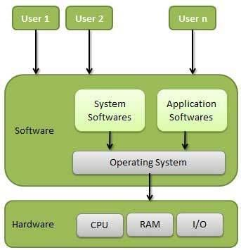
An operating system (OS) is a collection of software that manages computer hardware resources and provides common services for computer programs. The operating system is a vital component of the system software in a computer system.

Functions of operating system
An Operating System (OS) is an interface between a computer user and computer hardware. An operating system is a software which performs all the basic tasks like file management, memory management, process management, handling input and output, and controlling peripheral devices such as disk drives and printers.Some popular Operating Systems include Linux Operating System, Windows Operating System, VMS, OS/400, AIX, z/OS, etc..
- Memory Management
- Processor Management
- Device Management
- File Management
- Security
- Control over system performance
- Job accounting
- Error detecting aids
- Coordination between other software and users
Memory Management
Memory management refers to management of Primary Memory or Main Memory. Main memory is a large array of words or bytes where each word or byte has its own address.
Main memory provides a fast storage that can be accessed directly by the CPU. For a program to be executed, it must in the main memory. An Operating System does the following activities for memory management −
- Keeps tracks of primary memory, i.e., what part of it are in use by whom, what part are not in use.
- In multiprogramming, the OS decides which process will get memory when and how much.
- Allocates the memory when a process requests it to do so.
- De-allocates the memory when a process no longer needs it or has been terminated.
Processor Management
In multiprogramming environment, the OS decides which process gets the processor when and for how much time. This function is called process scheduling. An Operating System does the following activities for processor management −
- Keeps tracks of processor and status of process. The program responsible for this task is known as traffic controller.
- Allocates the processor (CPU) to a process.
- De-allocates processor when a process is no longer required.

Device Management
An Operating System manages device communication via their respective drivers. It does the following activities for device management −
- Keeps tracks of all devices. Program responsible for this task is known as the I/O controller.
- Decides which process gets the device when and for how much time.
- Allocates the device in the efficient way.
- De-allocates devices.
File Management
A file system is normally organized into directories for easy navigation and usage. These directories may contain files and other directions.
An Operating System does the following activities for file management −
Keeps track of information, location, uses, status etc. The collective facilities are often known as file system.
- Decides who gets the resources.
- Allocates the resources.
- De-allocates the resources.
- Other Important Activities
Security − By means of password and similar other techniques, it prevents unauthorized access to programs and data.
Control over system performance − Recording delays between request for a service and response from the system
Job accounting − Keeping track of time and resources used by various jobs and users.
Error detecting aids − Production of dumps, traces, error messages, and other debugging and error detecting aids.
Coordination between other softwares and users − Coordination and assignment of compilers, interpreters, assemblers and other software to the various users of the computer systems.
Types of Operating system
Operating systems are there from the very first computer generation and they keep evolving with time.
Batch operating system
The users of a batch operating system do not interact with the computer directly. Each user prepares his job on an off-line device like punch cards and submits it to the computer operator. To speed up processing, jobs with similar needs are batched together and run as a group. The programmers leave their programs with the operator and the operator then sorts the programs with similar requirements into batches.
Disadvantages
- Lack of interaction between the user and the job.
- CPU is often idle, because the speed of the mechanical I/O devices is slower than the CPU.
Time-sharing operating systems
Time-sharing is a technique which enables many people, located at various terminals, to use a particular computer system at the same time. Time-sharing or multitasking is a logical extension of multiprogramming. Processor's time which is shared among multiple users simultaneously is termed as time-sharing.
Multiple jobs are executed by the CPU by switching between them, but the switches occur so frequently. Thus, the user can receive an immediate response.
Advantages
- Provides quick response.
- Avoids duplication of software.
- Reduces CPU idle time.
Disadvantages
- Problem of reliability.
- security and integrity issues of user programs and data.
- Problem of data communication.
Distributed operating System
Distributed systems use multiple central processors to serve multiple real-time applications and multiple users. Data processing jobs are distributed among the processors accordingly.
The processors communicate with one another through various communication lines (such as high-speed buses or telephone lines). These are referred as loosely coupled systems or distributed systems. Processors in a distributed system may vary in size and function.
ADVANTAGES
- With resource sharing facility, a user at one site may be able to use the resources available at another.
- Speedup the exchange of data with one another via electronic mail.
- If one site fails in a distributed system, the remaining sites can potentially continue operating.
- Better service to the customers.
- Reduction of the load on the host computer.
- Reduction of delays in data processing.
Network operating System
A Network Operating System runs on a server and provides the server the capability to manage data, users, groups, security, applications, and other networking functions. The primary purpose of the network operating system is to allow shared file and printer access among multiple computers in a network, typically a local area network (LAN), a private network or to other networks.
Examples of network operating systems include Microsoft Windows Server 2003, Microsoft Windows Server 2008, UNIX, Linux, Mac OS
Advantages
- Centralized servers are highly stable.
- Security is server managed.
- Upgrades to new technologies and hardware can be easily integrated into the system.
- Remote access to servers is possible from different locations and types of systems.
Disadvantages
- High cost of buying and running a server.
- Dependency on a central location for most operations.
- Regular maintenance and updates are required.
Real Time operating System
A real-time system is defined as a data processing system in which the time interval required to process and respond to inputs is so small that it controls the environment. The time taken by the system to respond to an input and display of required updated information is termed as the response time.
A real-time operating system must have well-defined, fixed time constraints, otherwise the system will fail. For example, scientific experiments, medical image systems, industrial control systems, weapon systems, robots, air traffic control systems, etc.

Networks
Computer Network:
A computer network is created when several computers and terminal devices are connected together by data communication system. The set of computers may include microprocessors, mini computers, medium scale computers and large-scale computers. The set of terminal devices may include, dumb terminal, intelligent terminal, dumb as well as intelligent terminals etc. and miscellaneous devices such as modems, commonly used for data transmission. Each computer in a network can have its own processing capabilities and can also share computer hardware, programs, software, and data files.
The three basic types of computer networks are as follows:
- Local-area Networks.
- Metropolitan-Area Networks.
- Wide-Area Networks.

Local-Area Network (LAN)
A local area network (LAN) is two or more computers directly linked within a small well-defined area such as a room, office building, or a campus. A LAN can be made up of only microcomputer or any combination of microcomputer and large system. Main benefit of LAN is reduction of hardware and software costs because user can share several computers, peripheral devices such as laser printers, color printers, hard disk, and modems. Another benefit of LAN is the user can share the same data.
A LAN generally consists of the following.
- Two or more computers.
- Software to control the operations of the computers.
- Peripheral devices such as modems, printers, plotters etc.
- Coaxial or fiber optic cables are usually used to connect the computers and there devices.
- A plug-in board to handle the data transmissions.
Some LAN’s specifically requires all the computers to be of a certain brand while others allow a variety of brands to be connected. The number of computers in LAN varies widely from small LANs that connect two to twenty five computers, to large LANs that may connect more than 10,000 computers.
LAN must get the data to its destination, transmit the data correctly, and prevent unauthorized users from gaining access to that data.

Metropolitan-Area Networks:
A Metropolitan-Area Network (MAN) is a network that is larger then a LAN. It is called metropolitan since it normally covers the area of a city. Different hardware and transmission media are often used in MAN because they must efficiently cover these distances (a few tens to about one hundred kilometers).

Wide-Area Networks:
A Wide-Area Network (WAN) is two or more geographically dispersed computer, linked by communication facilities such as telecommunication or microwave relays. In other words, one of the most significant aspects of Wide-area network while comparing it with the freedom of a local-area network is the involvement of public telecommunication authority. WAN is usually limited to use by large organizations and government agencies due to high costs involved in building and maintaining them.
There are two specific categories of WAN,
- Enterprise: An enterprise network connects all LAN’S of a single organization. The term is normally used for networks connecting extremely large organization, or for those that cross regional boundaries.
- Global: By definition a global network is one that spans the earth. While global networks may not cover the entire globe, they cross multiple national boundaries and may include the networks of several organizations.

NETWORK TOPOLOGY:
Each computer or device in a network is called a node. The geometrical arrangement of computer resources, remote device and communication facilities are known as network topology.
A network topology can be made in one of the five different topologies.
- Bus network
- Ring Network
- Star Network
- Tree Network
- Mesh Network

1. Bus Network
In a bus network, each computer is connected to a single communication cable via an interface and every computer can directly communicate with every other computer or device in the network. This topology is commonly used along with the local area networks.
Advantages of the Bus Network
- Short cable length and simple wiring layout: Because there is a single common data path connecting to all nodes, the bus topology allows a very short cable length to be used. This decreases the installation cost and also leads to a simple, easy to maintain wiring layout.
- Reliable architecture: The bus architecture has an inherent simplicity that makes it very reliable from a hardware point of view. There is a single cable through which all data passes and to which all nodes are connected.
- Easy to extend: Additional nodes can be connected to an existing bus network at any point along its length.

Disadvantages of the Bus Network
- Fault diagnosis is difficult: Although the simplicity of the bus topology means that there is very little that can go wrong, fault detection is not a simple matter. In most LANs based on a bus, control of the network is not centralized in any particular node. This means that detection of a fault may be performed from many points in the network.
- Fault isolation is difficult: If a node is faulty on a bus, it must be rectified at the point where the node is connected to the network.
- Repeater configuration: When a bus network has its backbone extended using repeaters, reconfiguration may be necessary, this may involve additional cable lengths and adjusting terminators, etc.
- Nodes must be intelligent: Each node on the network is directly connected to the central bus, this mean that some way of deciding who can use the network at any given time must be performed in each node. It tends to increase the cost of the nodes.

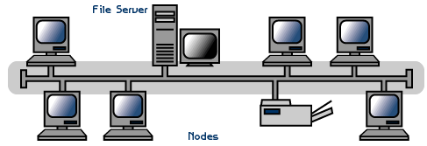

2. Ring Network

In a ring network, several devices or computers are connected to each other in a closed loop by a single communication cable that is why a ring network is also called loop network. In the ring network, data must travel around the ring to each station in turn until they arrive at the required station. A thing can be unidirectional or bi-directional. In a unidirectional ring, data moves in one direction only, and in a bi-directional ring, data moves in both directions, but in only one direction at a time.

Advantages of the Ring Network

Short cable length: This means that fewer connections will be needed, which will in turn increase network reliability.

No wiring closet space required: Since there is only one cable connecting each node to its immediate neighbors, it is not necessary to allocate space in the building for wiring closets.

Suitable for optical fibers: Optical fibers offer the possibility of very high speed transmission. Because traffic on a ring travels in one direction, it is easy to use optical fibers as a medium of transmission.

Disadvantages of the Ring Network

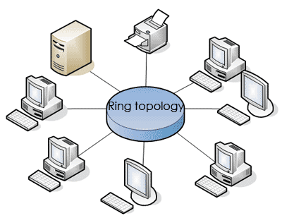
Node failure causes network failure: The transmission of data on a ring goes through every connected node on the ring before returning to the sender. If one node fails to pass data though itself, the entire network has failed and no traffic can flow until the defective node has been removed from the ring.

Difficult to diagnose faults: The fact that failure of one node will affect all others has serious implications for fault diagnosis. It may necessary to examine a series of adjacent nodes to determine the faulty one.

Network reconfiguration is difficult: It is not possible to shut down a small section of the ring while keeping the majority of it working normally.

Topology affects the access protocol: Each node on a ring has a responsibility to pass on data that it receives. This means that the access protocol must take this in to account. Before a node can transmit its own data, it must ensure that the medium is available for use.

3. Star Network
In star network, several devices or computers are connected to one centralized computer; the main disadvantage of star network is that none of the other computer can communicate with each other if the central computer breaks down.
Advantages of the Star Network:

- Ease of service: The star topology has a number of concentration points, these provides easy access for service of reconfiguration of the network.

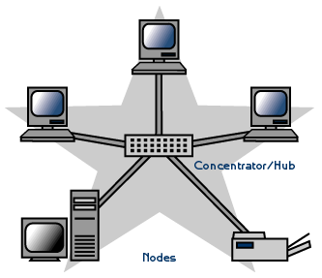
One device per connection: In star topology, failure of a single connection typically involves disconnecting one node from an otherwise fully functional network.

Centralized control/problem diagnosis: The fact that the central node is connected directly to every other node in the network means that faults are easily detected and isolated.

Simple access protocols: Any given connection involves only the central node and one peripheral node makes the access protocols very simple.

Disadvantages of the Star Network

Long cable length: Because each node is directly connected to the center, the star topology necessitates a large quantity of cable.

Difficult to expand: The addition of a new node involves a connection all the way to the central node. Problems can arise if a longer cable length is needed or an unanticipated concentration of nodes is required.

Central node dependency: If the central node in a star network fails, the entire network is rendered inoperable.

4. Tree Network
In a tree network, several devices or computers are linked in a hierarchical form. It is also known as hierarchical network. This type of distribution system is commonly used in the organization, where head quarters communicate with regional offices and regional offices communicates with district offices and so on.

Advantages of the Tree Network

Easy to extend: Because the tree is, of its very nature, divided into subunits, it is easier to add new nodes or branches to it.

Fault isolation: It is possible to disconnect whole branches of the network from the main structure. This makes it easier to isolate a defective node.
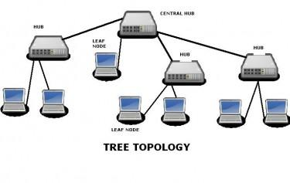

Disadvantages of the Tree Network
- Dependent on the root: if the “head end” device fails to operate, the entire network is in operative.

5. Mesh Network
Mesh network has point-to-point connection between every device in the network. Each device requires an interface for every other device on the network. Mesh topologies are not usually considered practical, in addition unless each station frequently sends signals to all the other station, an excessive amount of network bandwidth.

Advantages of the Mesh Network

Units affected by media failure: Mesh topologies resist media failure better than other topologies. Implementations that include more than two devices will always have multiple paths to send signals from one device to another. If one path fails, the transmission signals can be routed around the failed link.
- Easy for troubleshooting: Mesh network are easy to trouble shoot because, each medium link is independent of all other devices.

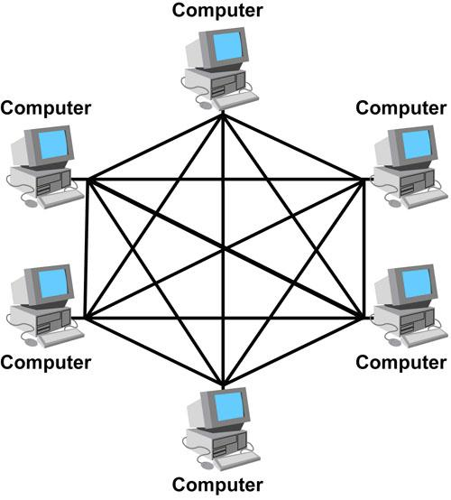
Disadvantages of the Mesh Network
- Difficult to install: Mesh networks are relatively difficult to install because each device must be linked directly to all other devices, as the number of devices increases, the difficulty of installation increases geometrically.
- Difficult to reconfigure: Mesh topologies are difficult to reconfigure for the same reasons that they are difficult to install.

